8th Presidium

3rd General Presidency

| **Supreme Secretary** United Socialist Republics | **EXECUTIVE ORDER #00.00.08**  **APPROPROPRIATE SOCIALIST RELATIONSHIPS ACT** |
| --- | --- |

**____________________________________________________________________________**

By the authority vested within me as Supreme Secretary of the United Socialist Republics by the Constitution and Basic Law, I Terry A. McKeen of the All Union Communist Party and of Zeprana hereby enact the following:

**Article I:**

All citizens within the United Socialist Republics shall have a Social Credit Score -

1. All citizens Social Credits shall be logged in the All-Union Grand Database of Citizens.

**Article II:**

The Social Credit Score of all citizens to begin shall be a unit of “100,000”.

**Article III:**

If one's social credit is above 100,000 - they shall have the following privileges:

1. Access to exclusive luxury resorts and accommodations.
2. Priority seating and boarding on public transportation.
3. Discounted rates on healthcare services.
4. Enhanced social benefits and welfare provisions.
5. Expedited processing for government services and applications.
6. Priority access to educational resources and opportunities.
7. Exclusive access to cultural and entertainment events.
8. Preferred status for employment and career advancements.
9. Higher priority for housing allocation.
10. Enhanced travel privileges, including visa-free access to select countries.

**Article IV:**

If one's social credit is below 100,000 - they shall have the following privileges revoked, gradually more restrictions as their credit drops lower:

90,000: Slight delays in processing government documentation. Restricted access to certain public facilities and venues.

89,000: Increased scrutiny in financial transactions and credit applications. Limited access to specialized services and resources.

88,000: Restricted access to certain educational resources and opportunities. Reduced eligibility for government-funded initiatives and programs.

87,000: Limited access to certain public transportation benefits. Increased reporting requirements for financial transactions.

86,000: Restricted access to certain cultural and entertainment events. Limited participation in government-sponsored activities.

85,000: Reduced eligibility for low-interest loans and financial assistance. Limited access to public healthcare services.

84,000: Increased monitoring and reporting of personal activities. Limited access to employment opportunities and career advancements.

83,000: Restricted access to certain government services and benefits. Limited access to social welfare support.

82,000: Slight delays in processing government service requests. Reduced priority for housing allocation.

81,000: Limited access to premium healthcare services. Restricted access to certain public facilities.

80,000: Increased surveillance and monitoring of personal activities. Limited access to specialized education and training programs. 79,000: Reduced eligibility for certain social benefits and welfare provisions. Limited participation in government-funded initiatives. 78,000: Restricted access to certain venues and establishments. Increased reporting requirements for financial transactions.

77,000: Limited access to public transportation benefits. Reduced eligibility for government-sponsored programs.

76,000: Slight delays in processing government documentation. Restricted access to certain public resources.

75,000: Increased scrutiny in financial transactions and credit applications. Limited access to specialized services and resources.

*Signed,*

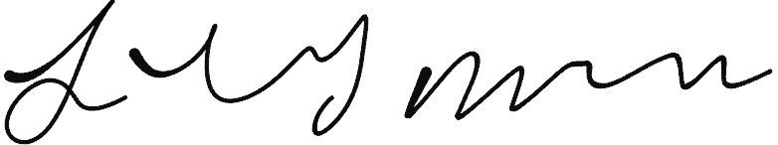

***Terry A. McKeen III,***

***Supreme Secretary of the USR***